Seasons
# Source: AI Source: Provided by: [Data Path: Persons Table -> ID Column: 1, Name_En Column: Motasem Essam] -> From: [ChatGPT] on [7/17/2026]
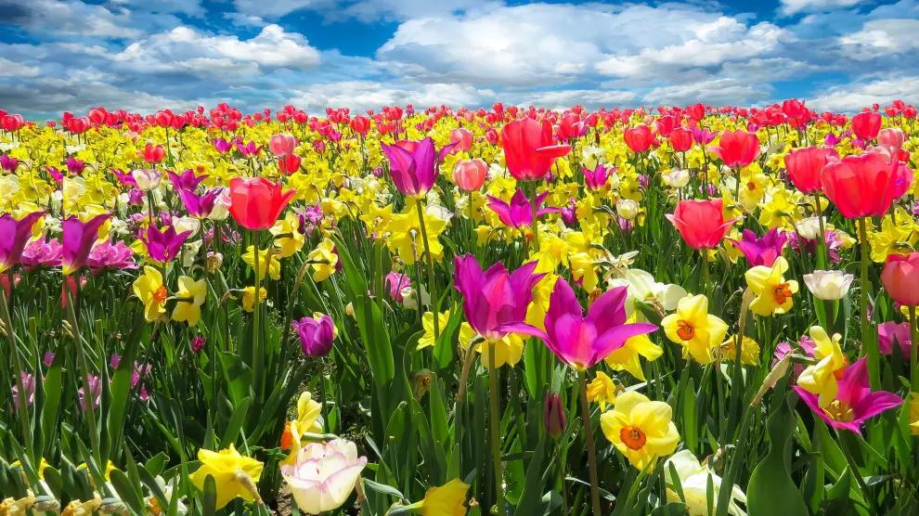

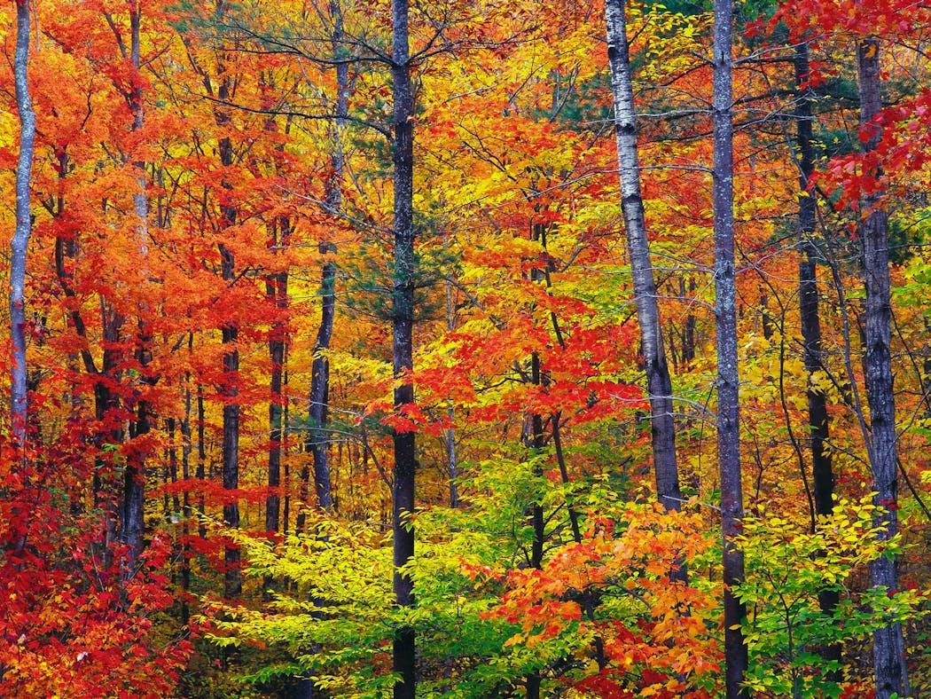
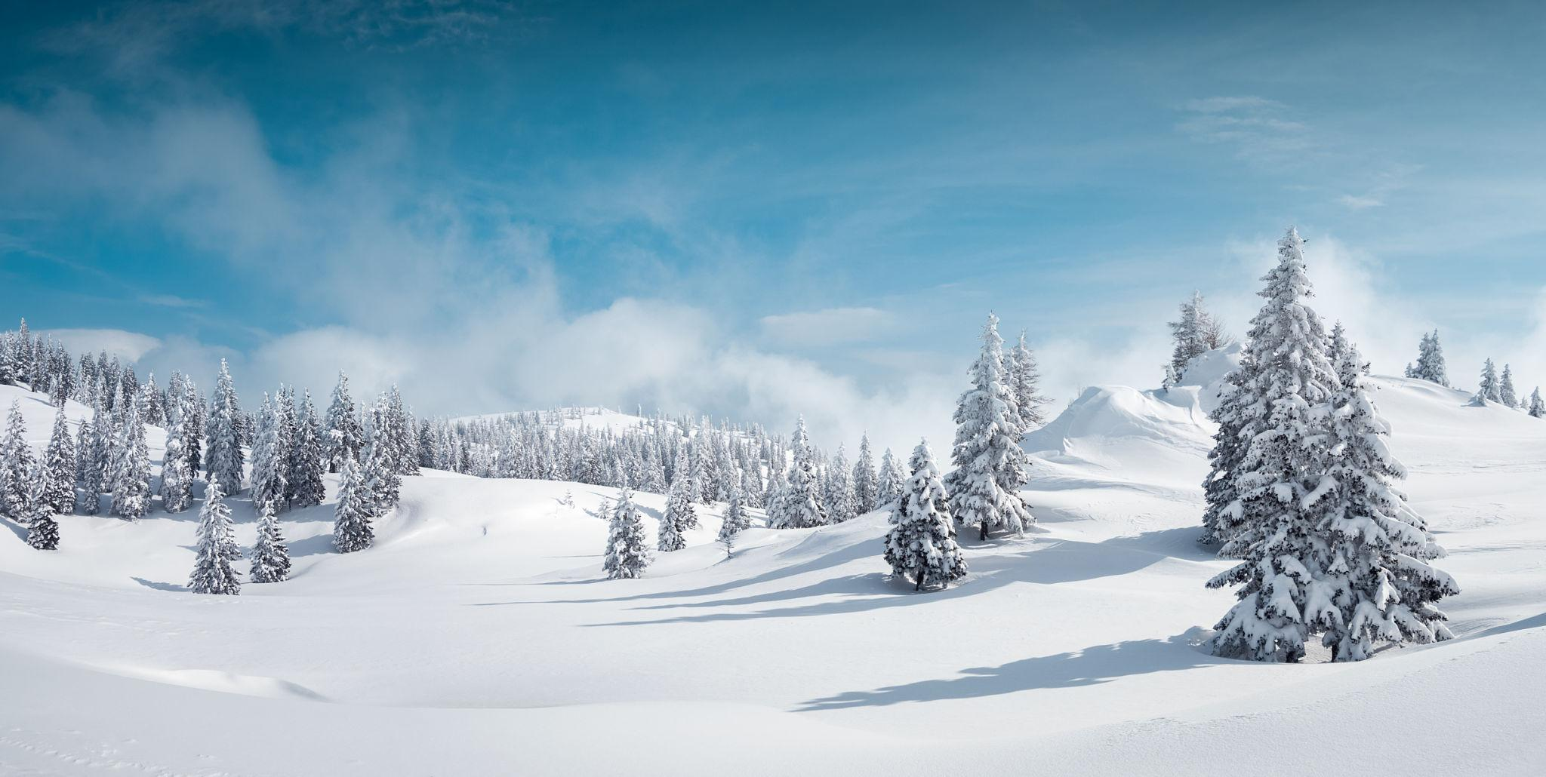
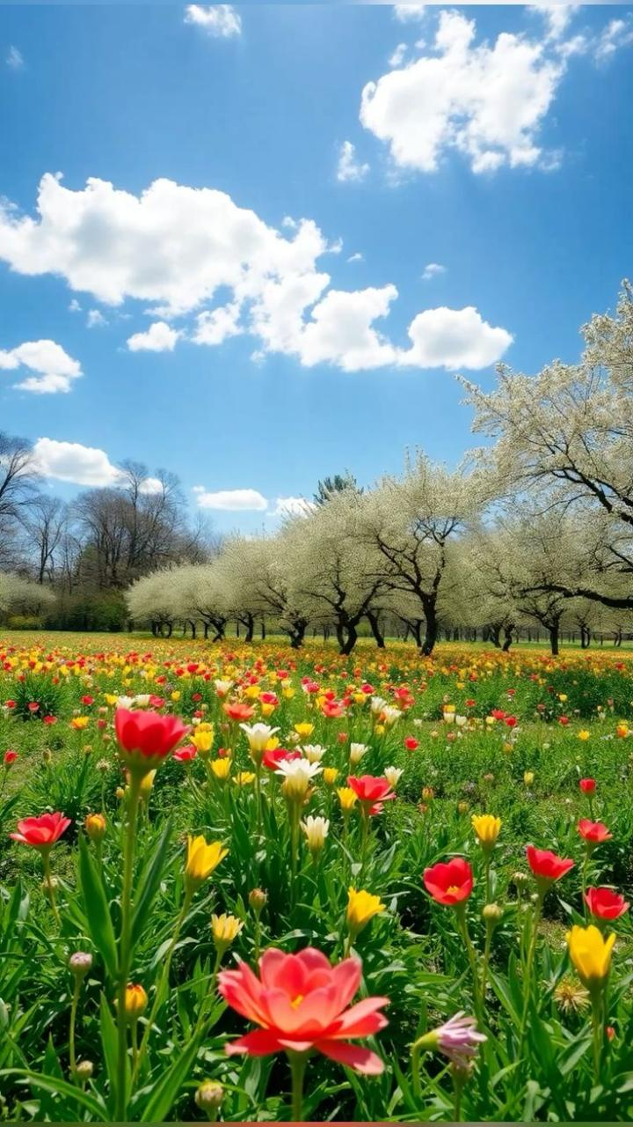
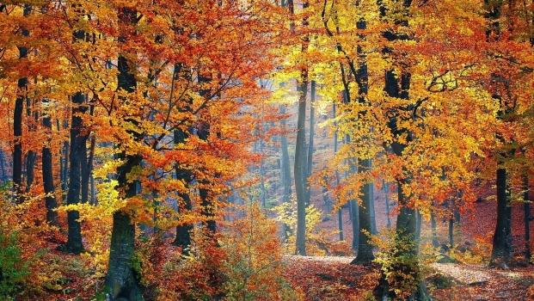
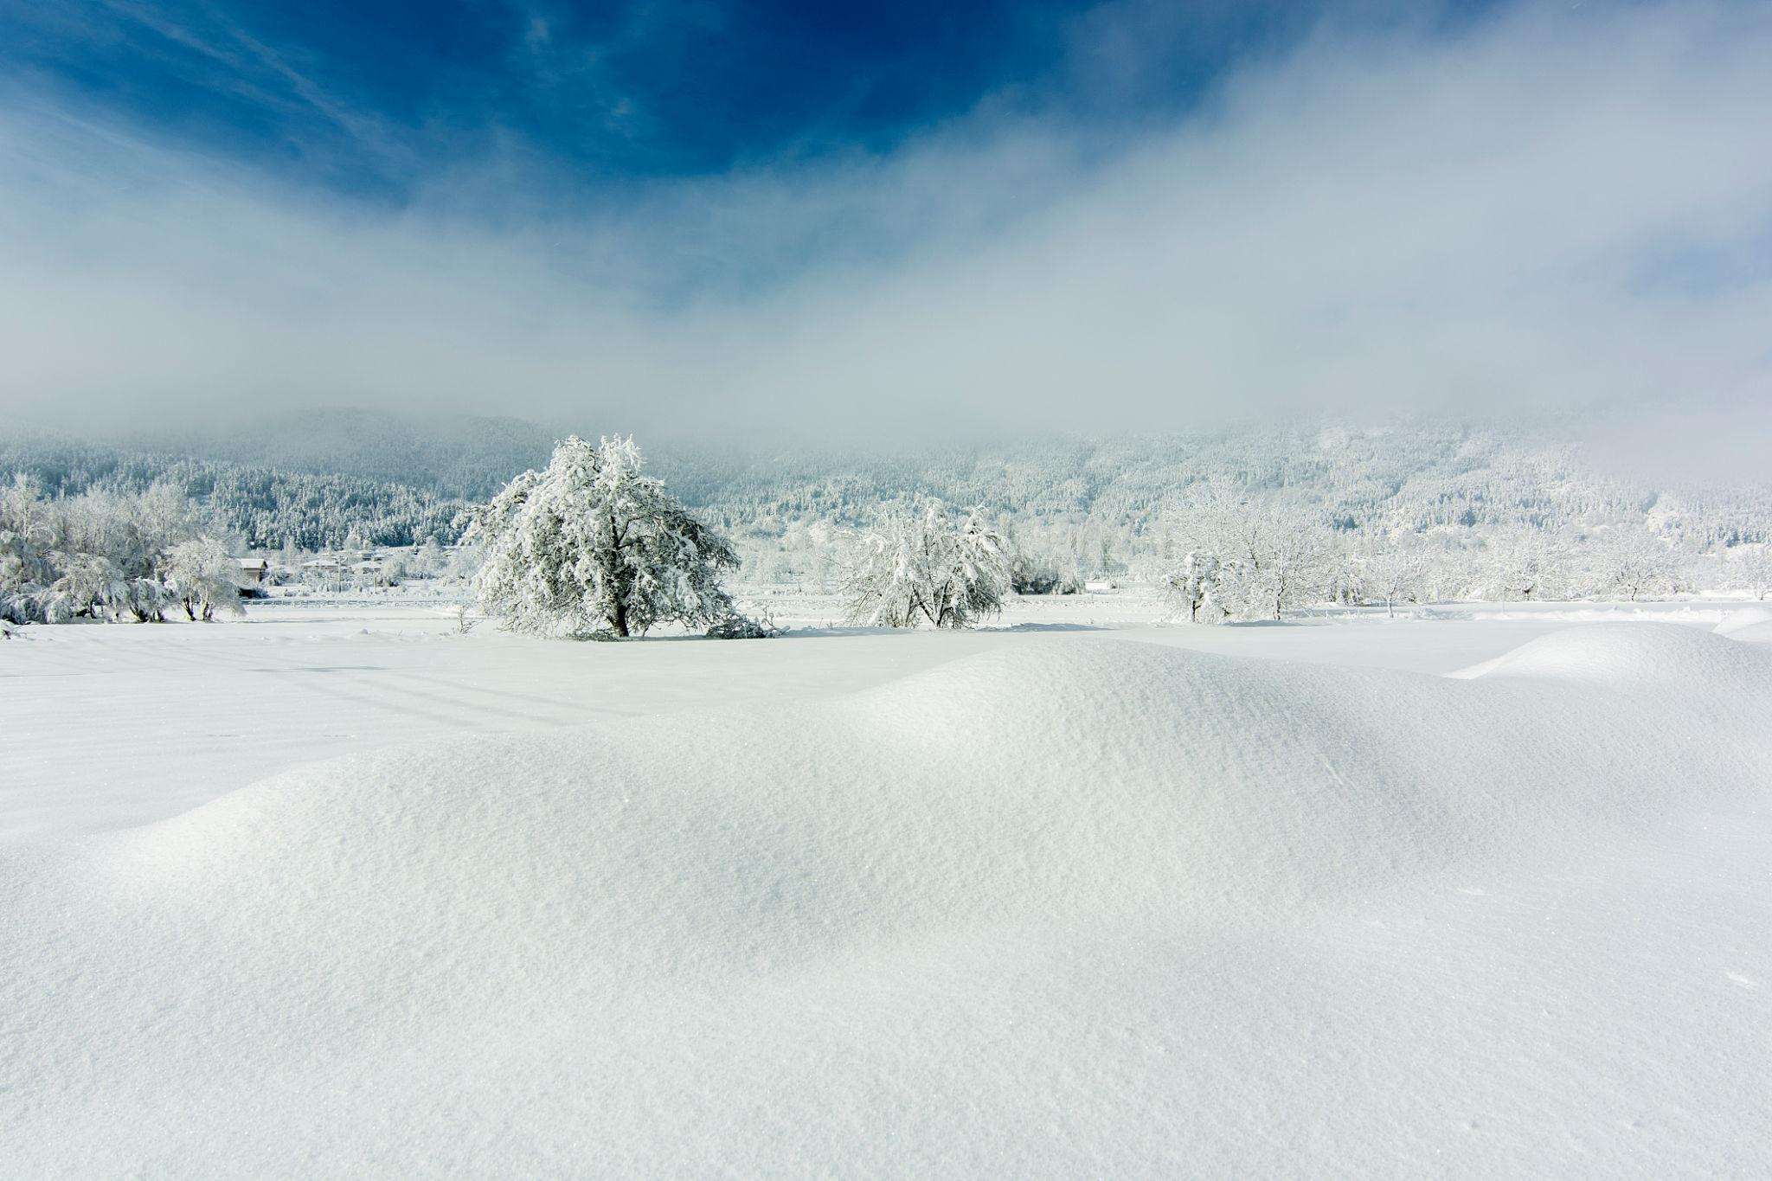
The Seasons are the four divisions of the year characterized by recurring changes in weather, temperature, daylight, and the natural environment. Seasons occur because the Earth's axis is tilted about 23.5° relative to its orbit around the Sun, causing different parts of the Earth to receive varying amounts of sunlight throughout the year.
The changing solar angle that creates the seasons is illustrated below.
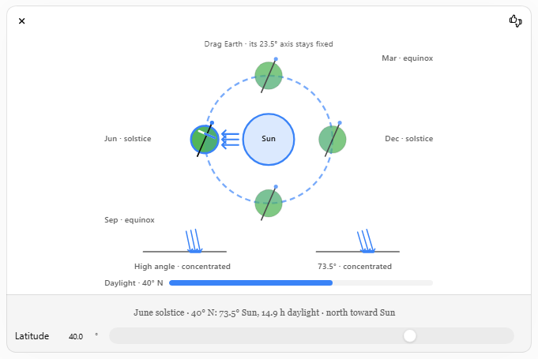

Definition
# Source: AI Source: Provided by: [Data Path: Persons Table -> ID Column: 1, Name_En Column: Motasem Essam] -> From: [ChatGPT] on [7/17/2026]
Seasons are recurring periods of the year resulting from the Earth's axial tilt and its revolution around the Sun, producing regular changes in climate, daylight, and temperature.

Purpose
# Source: AI Source: Provided by: [Data Path: Persons Table -> ID Column: 1, Name_En Column: Motasem Essam] -> From: [ChatGPT] on [7/17/2026]
Understanding seasons helps people:
- Plan agricultural activities.
- Predict climate patterns.
- Organize school and business calendars.
- Schedule cultural and religious events.
- Study ecosystems and environmental changes.

Why Do Seasons Occur?
# Source: AI Source: Provided by: [Data Path: Persons Table -> ID Column: 1, Name_En Column: Motasem Essam] -> From: [ChatGPT] on [7/17/2026]
Seasons are caused by two factors working together:
- Earth's axial tilt (approximately 23.5°).
- Earth's revolution around the Sun (about 365.24 days).
Because the Earth's axis remains tilted in the same direction as it orbits the Sun:
- One hemisphere receives more direct sunlight while the other receives less.
- Six months later, the situation reverses.

The Four Seasons

1. Spring
# Source: AI Source: Provided by: [Data Path: Persons Table -> ID Column: 1, Name_En Column: Motasem Essam] -> From: [ChatGPT] on [7/17/2026]
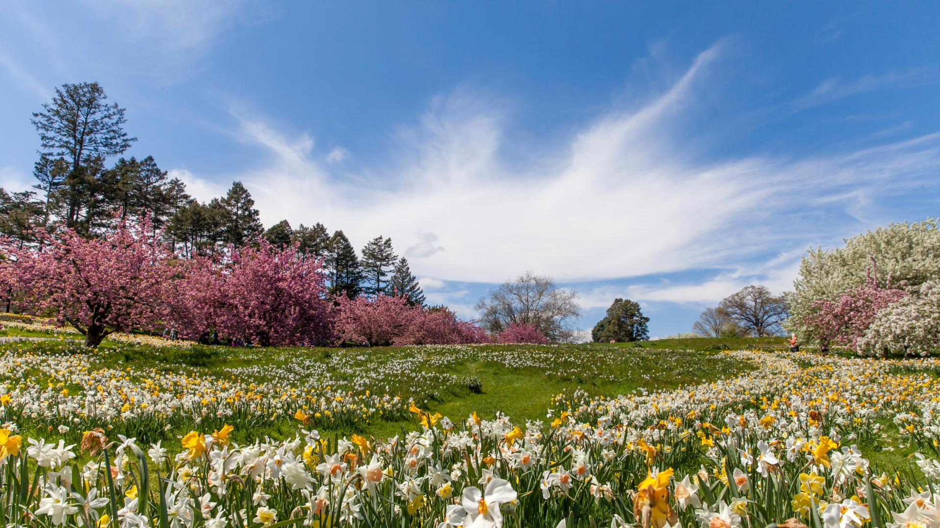
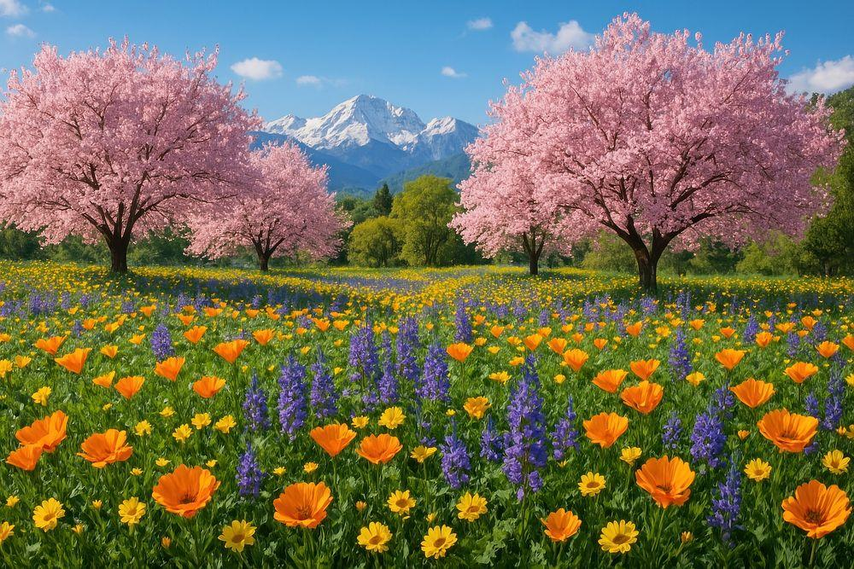
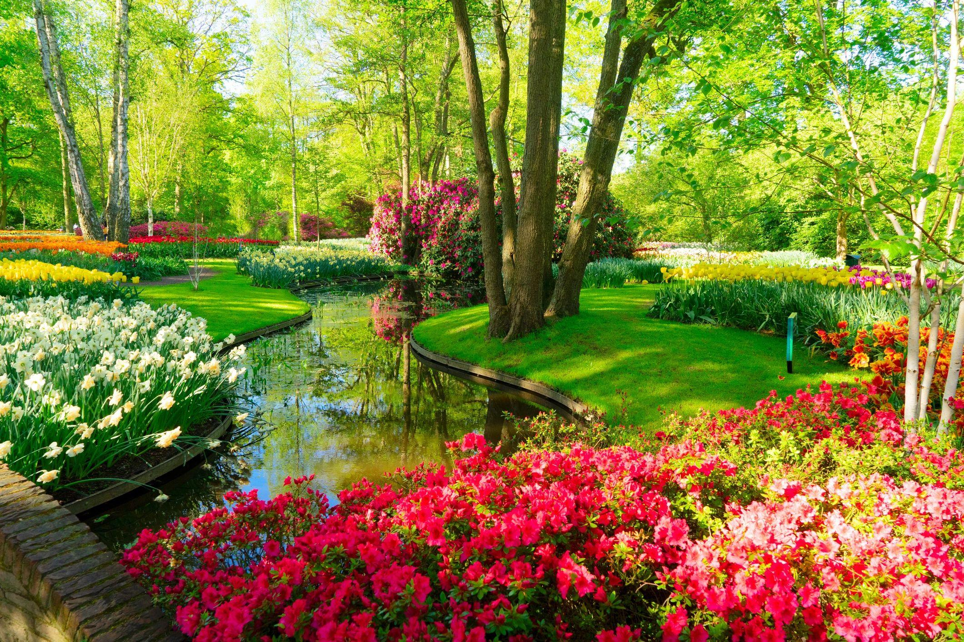
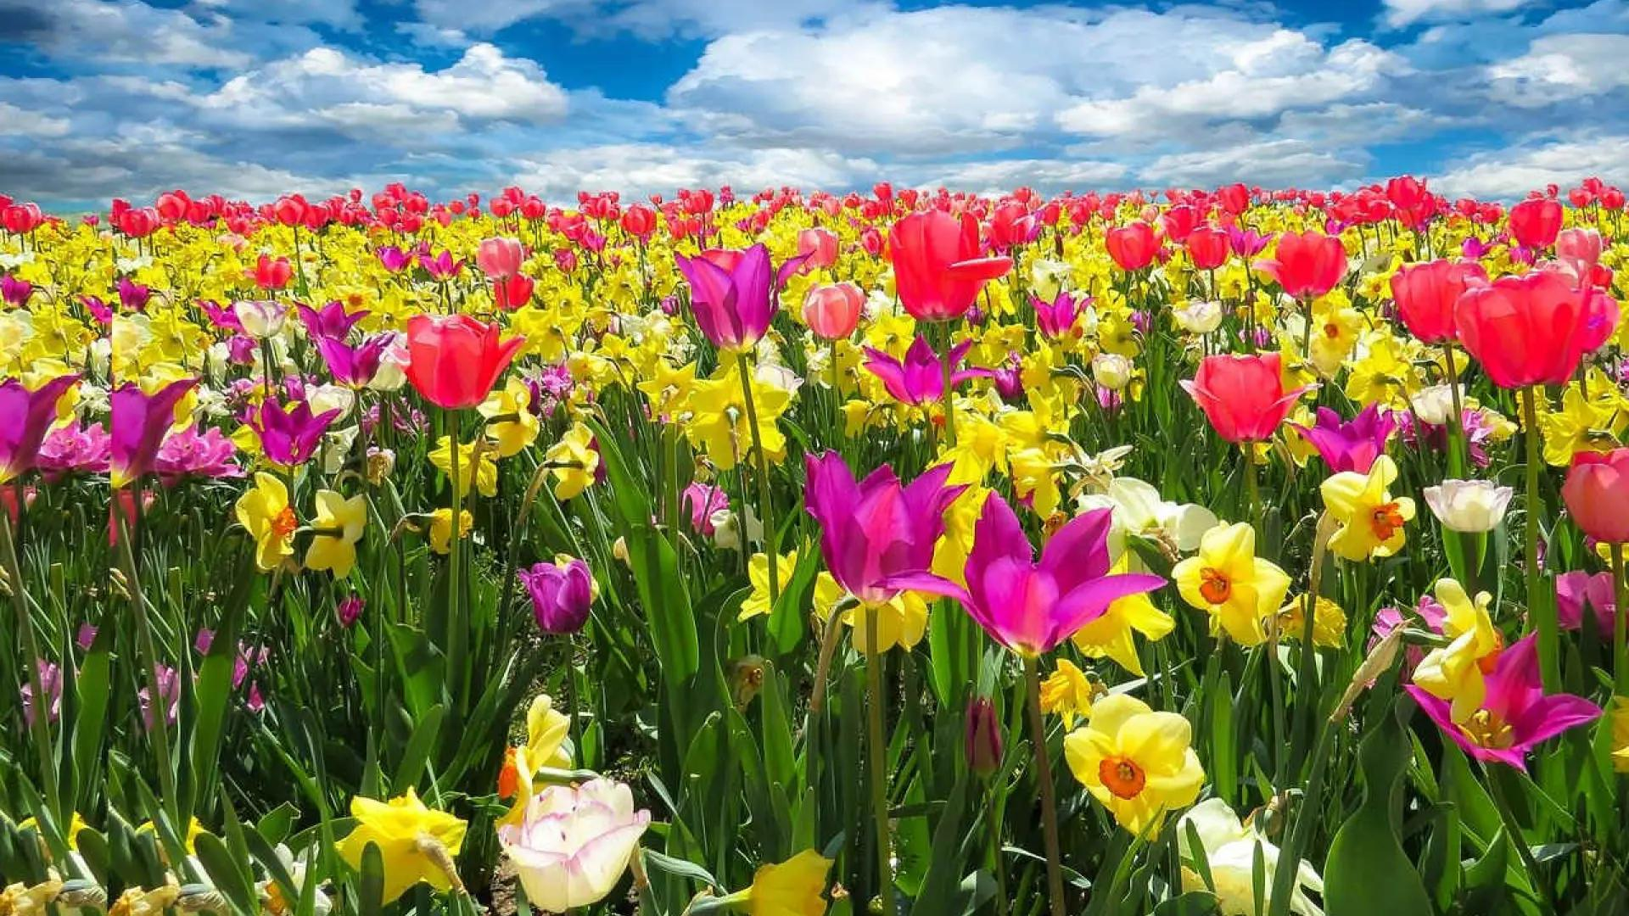
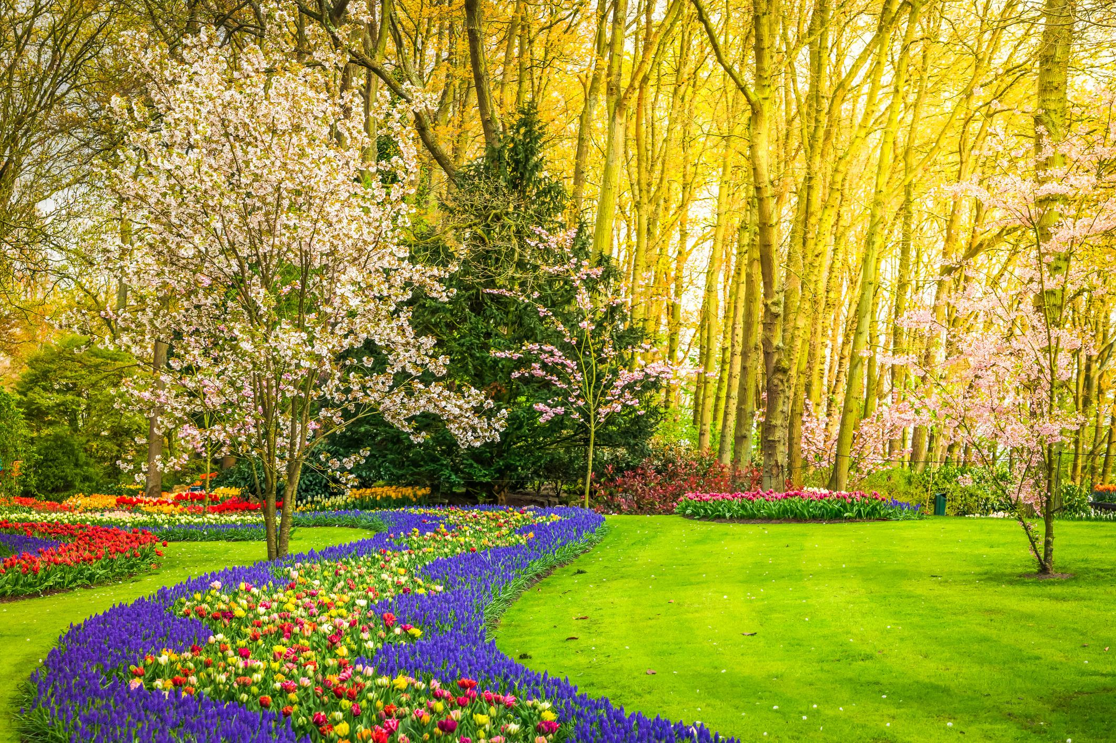
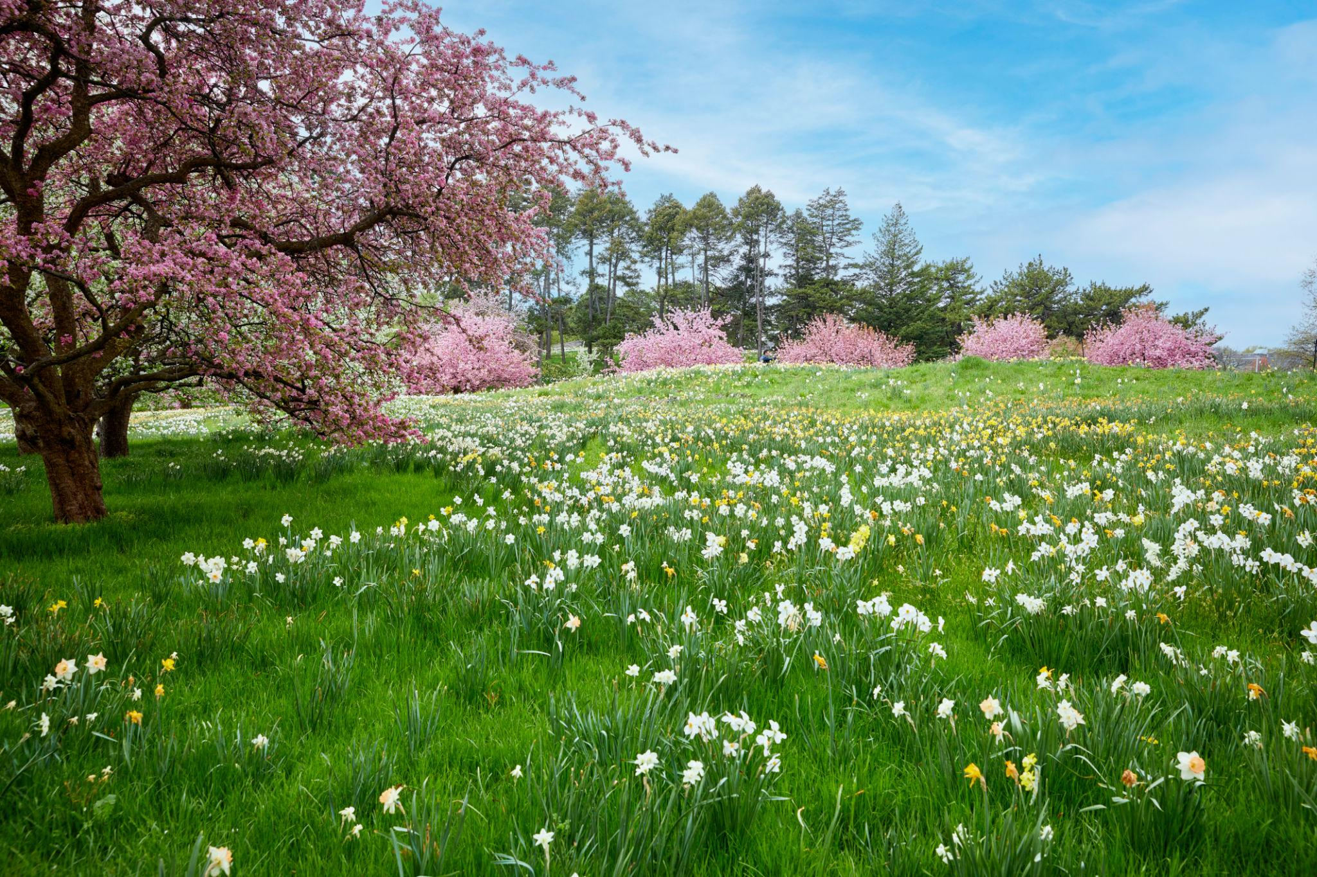
Characteristics
- Temperatures become warmer.
- Plants begin to grow.
- Flowers bloom.
- Trees produce new leaves.
- Daylight increases.
Typical months (Northern Hemisphere):
- March
- April
- May

2. Summer
# Source: AI Source: Provided by: [Data Path: Persons Table -> ID Column: 1, Name_En Column: Motasem Essam] -> From: [ChatGPT] on [7/17/2026]
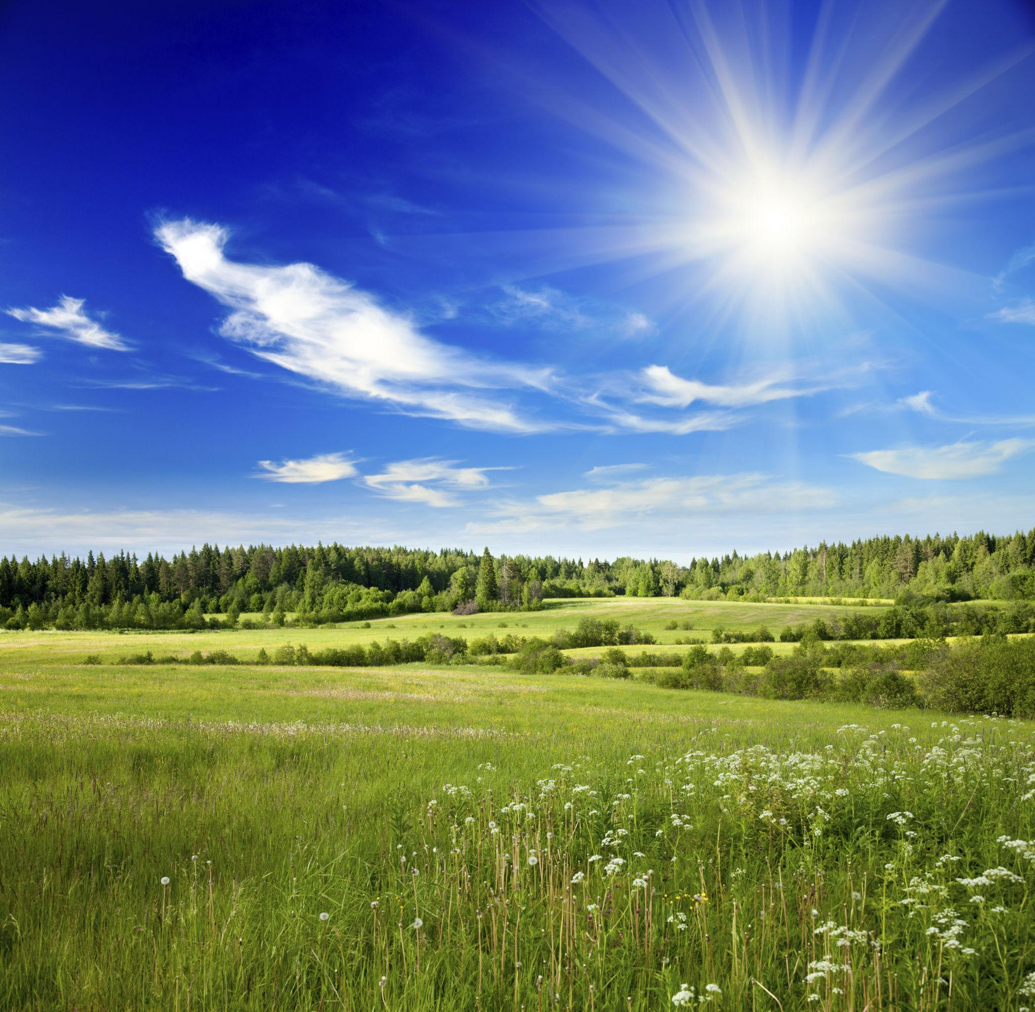
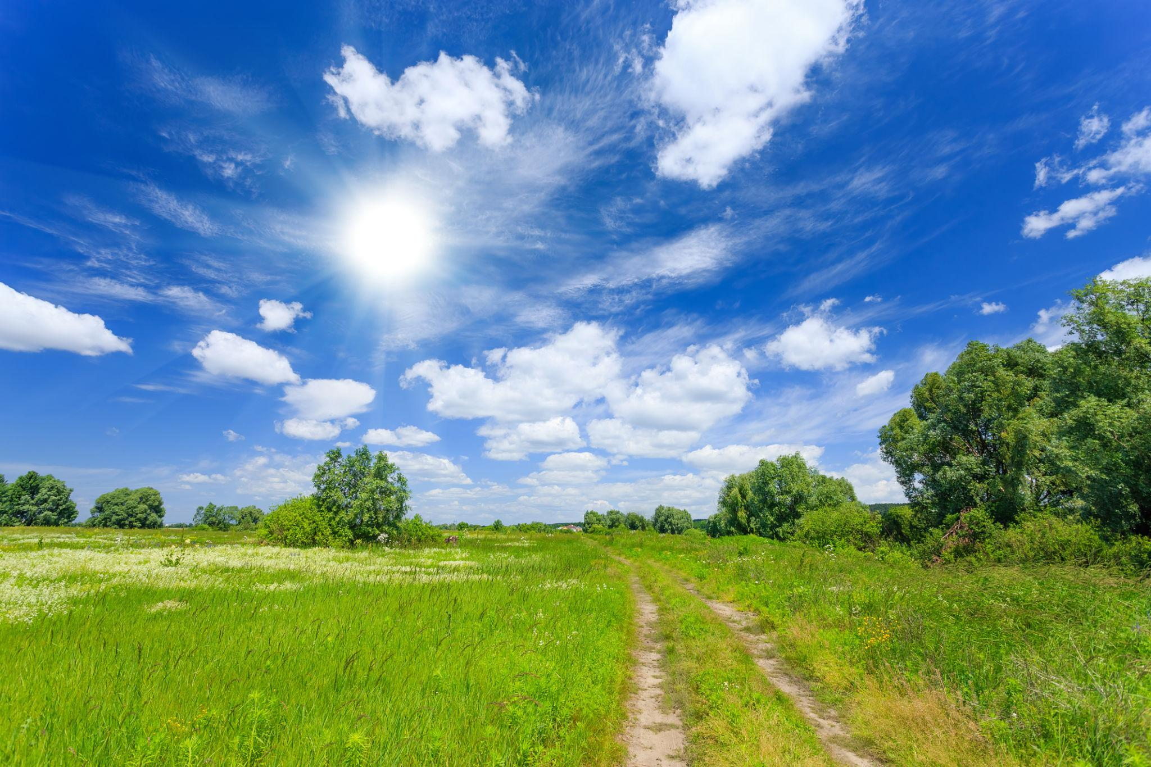
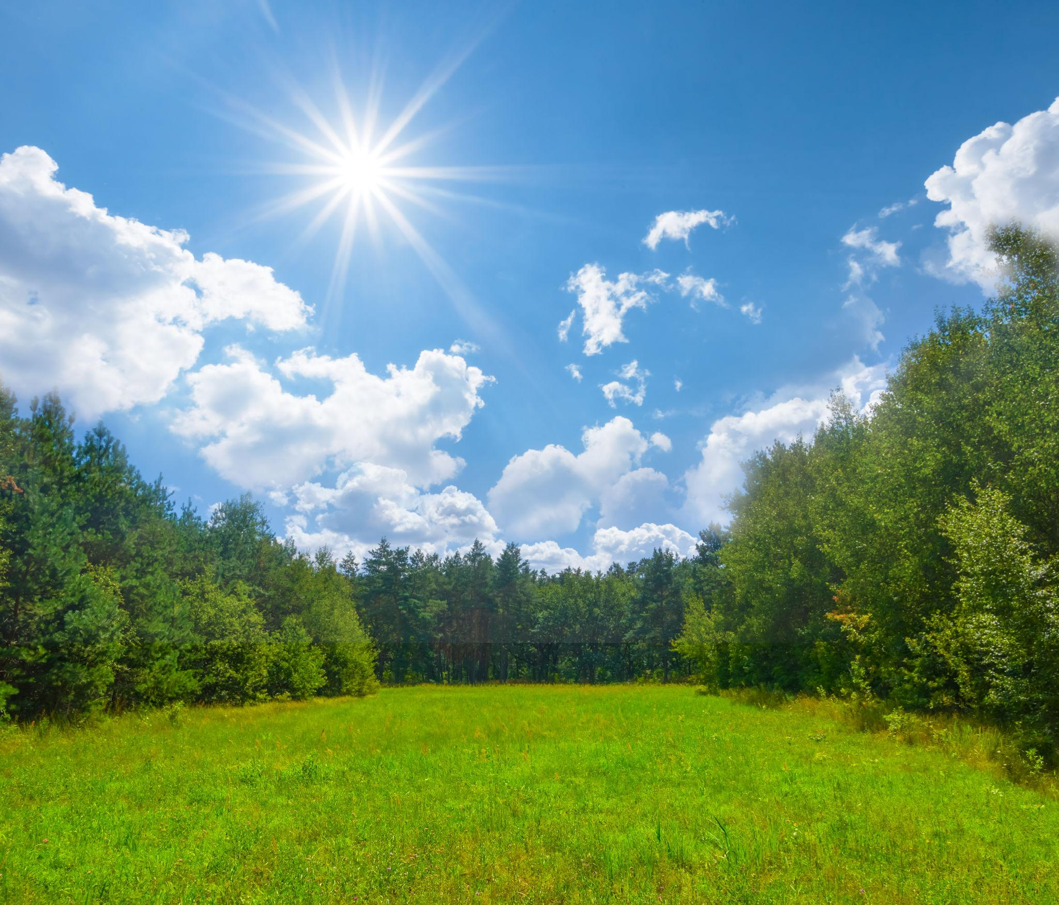
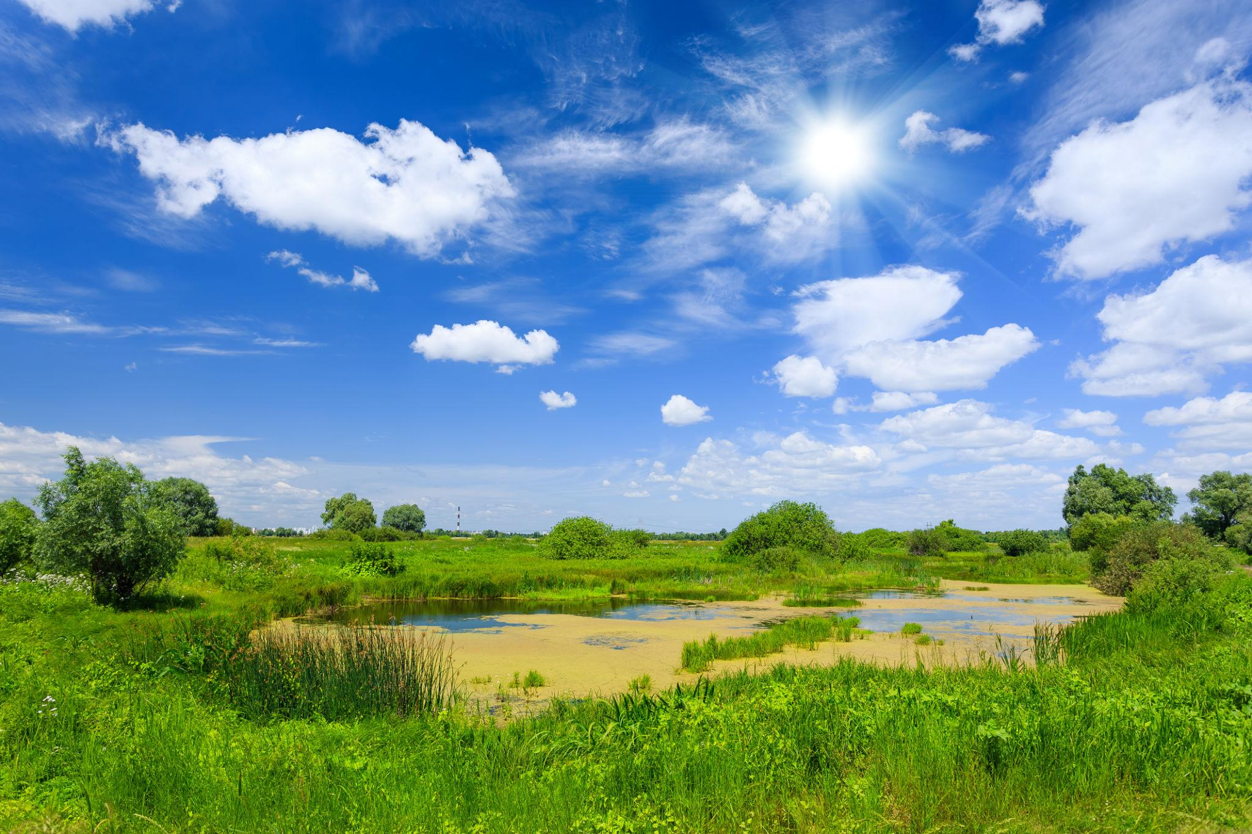
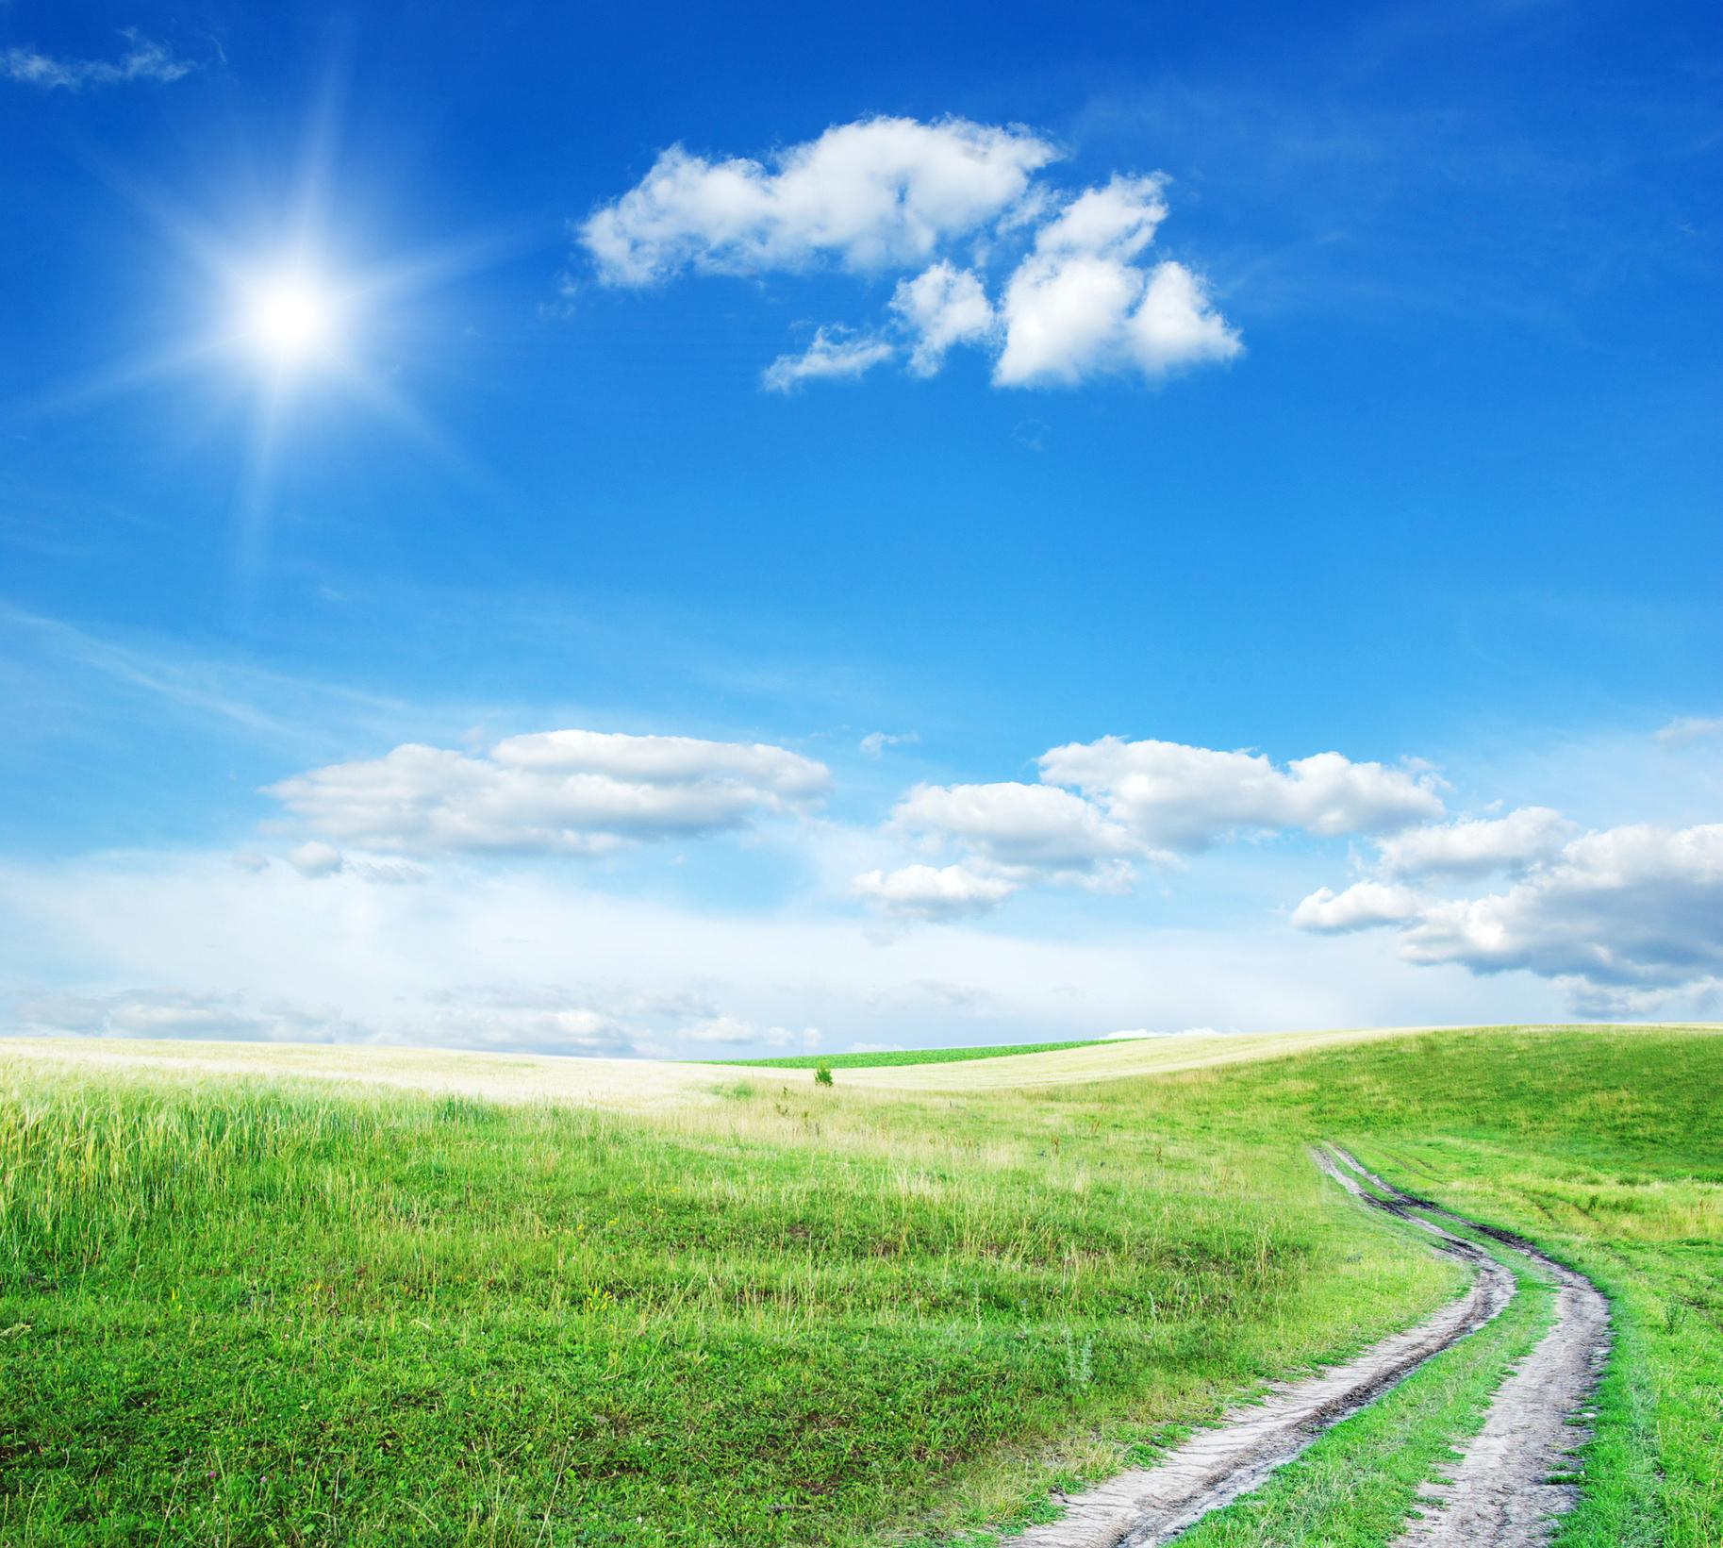
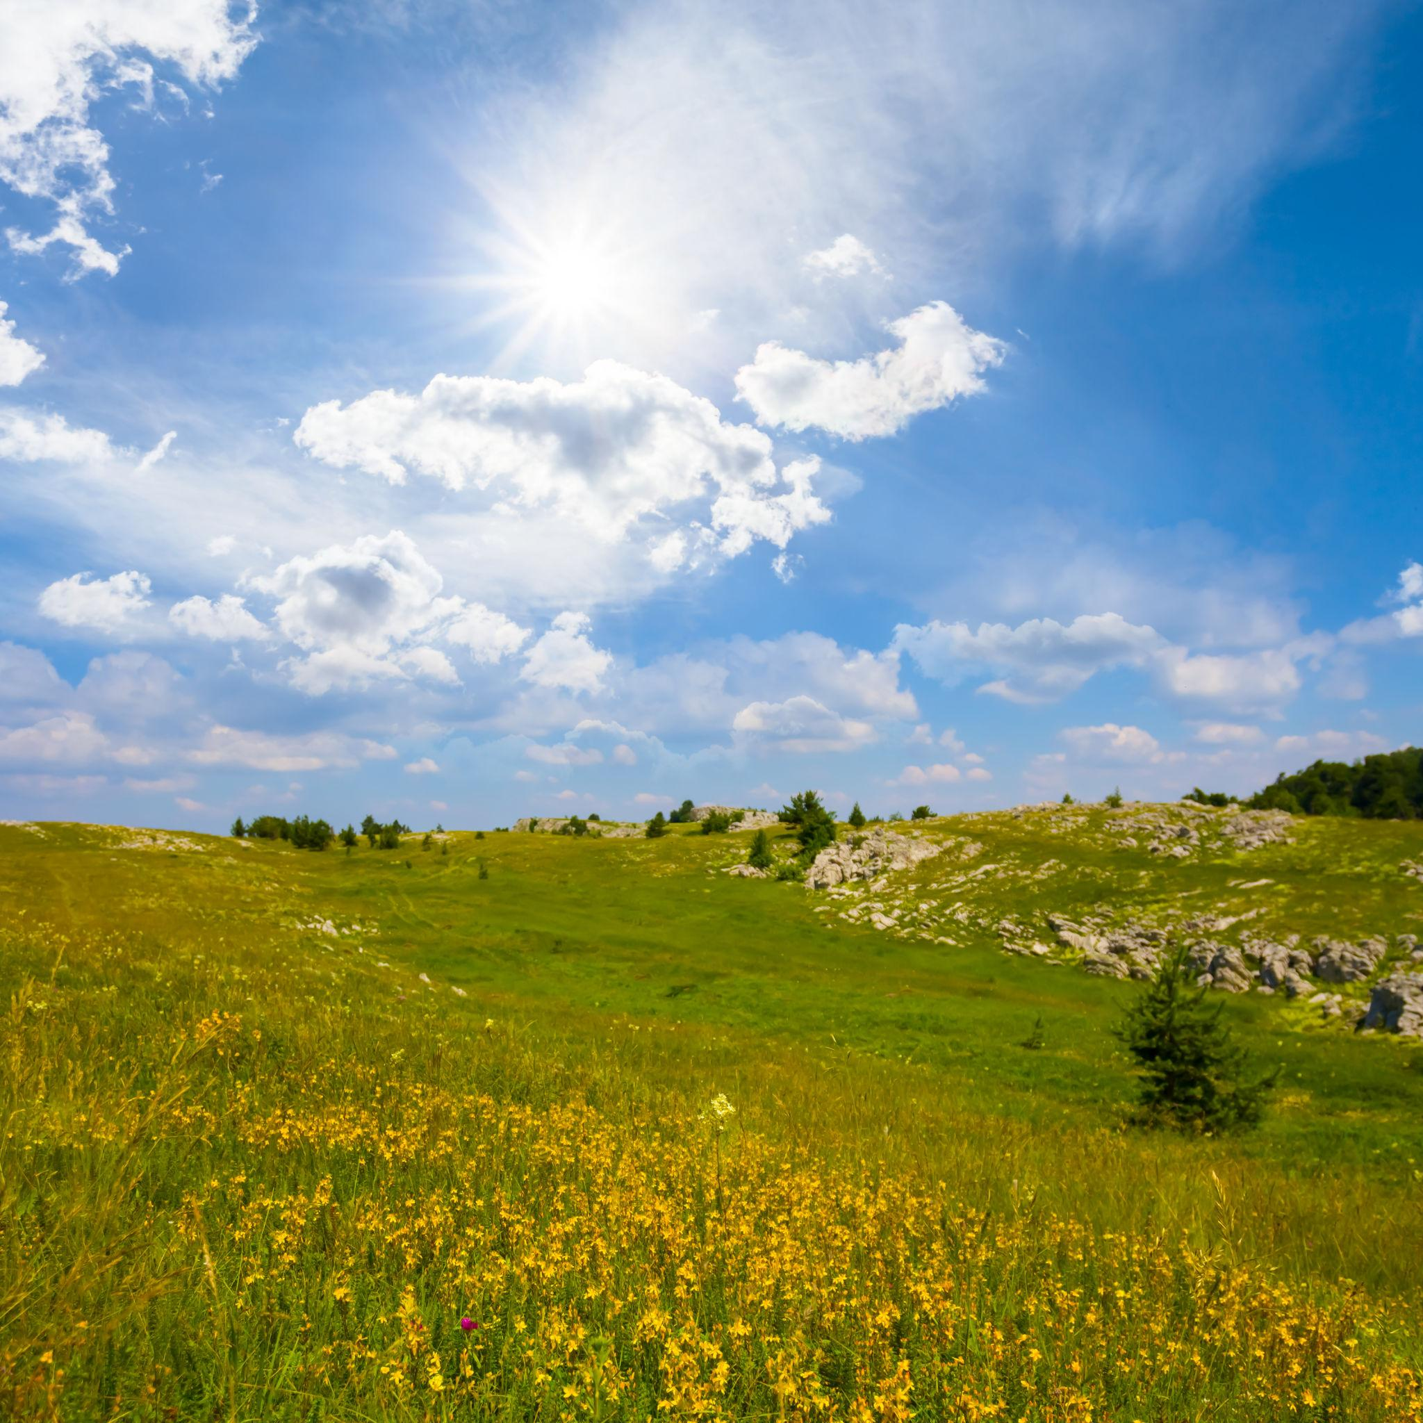
Characteristics
- Highest temperatures.
- Longest daylight hours.
- Active plant growth.
- Warm weather.
Typical months (Northern Hemisphere):
- June
- July
- August

3. Autumn (Fall)
# Source: AI Source: Provided by: [Data Path: Persons Table -> ID Column: 1, Name_En Column: Motasem Essam] -> From: [ChatGPT] on [7/17/2026]
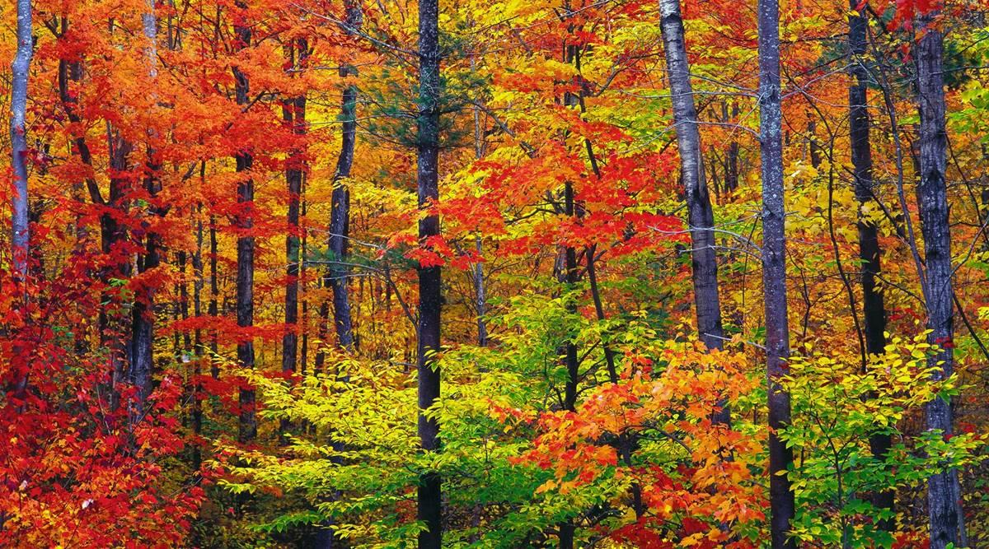
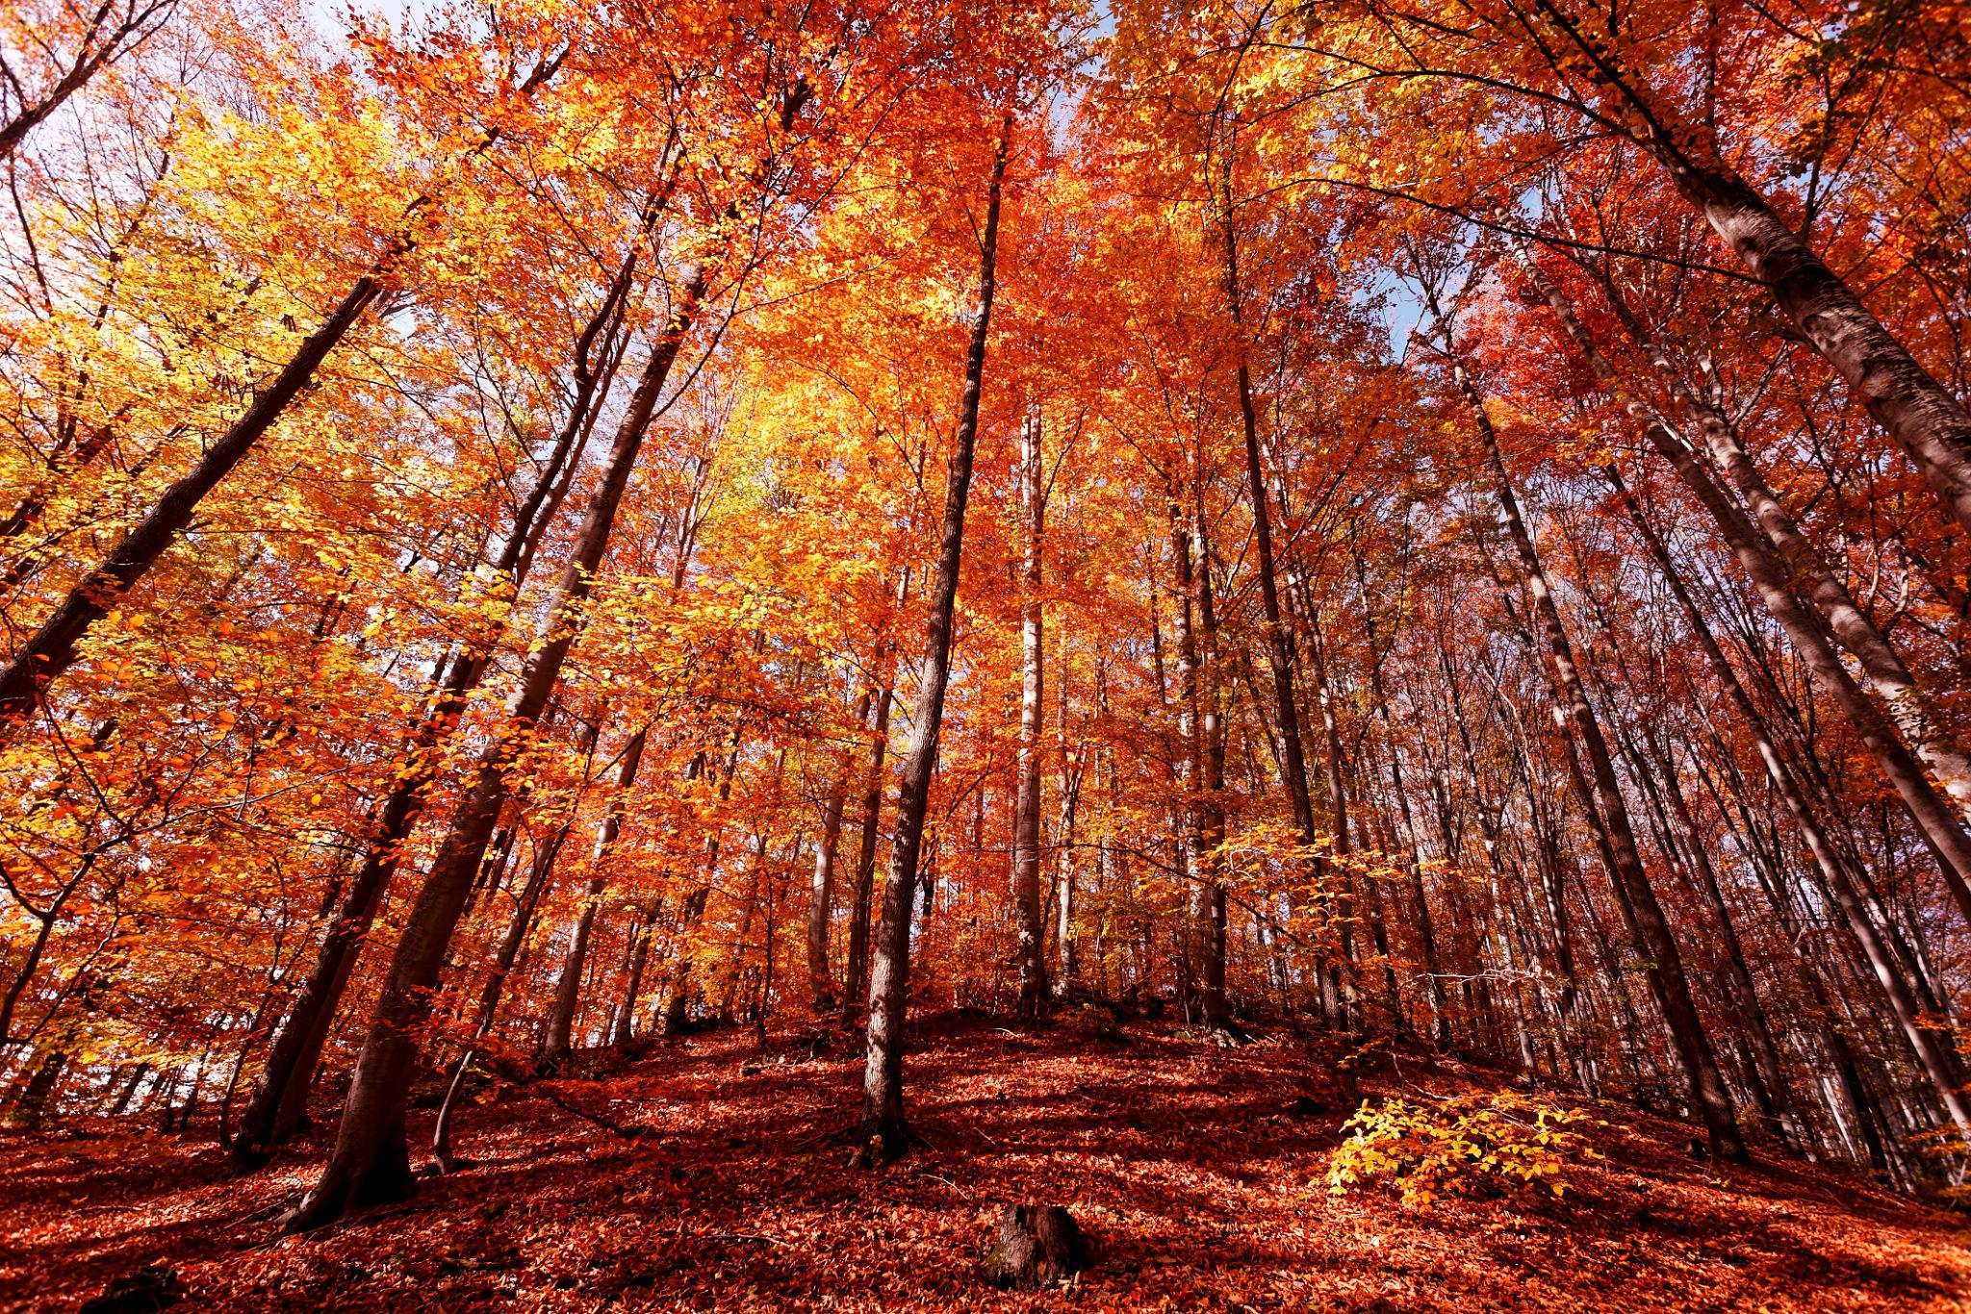
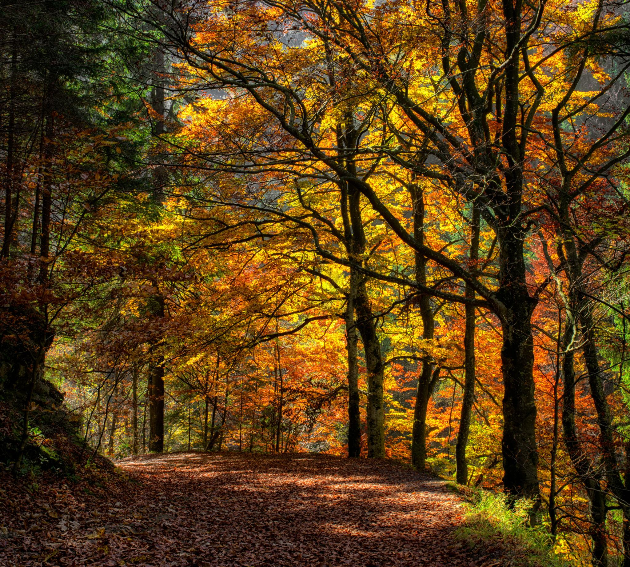
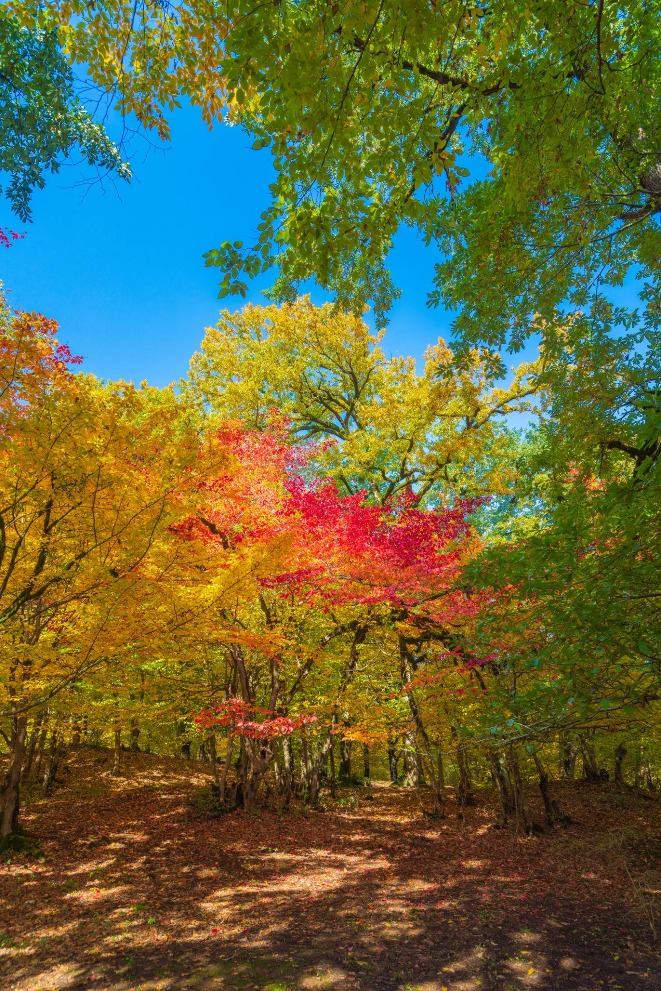
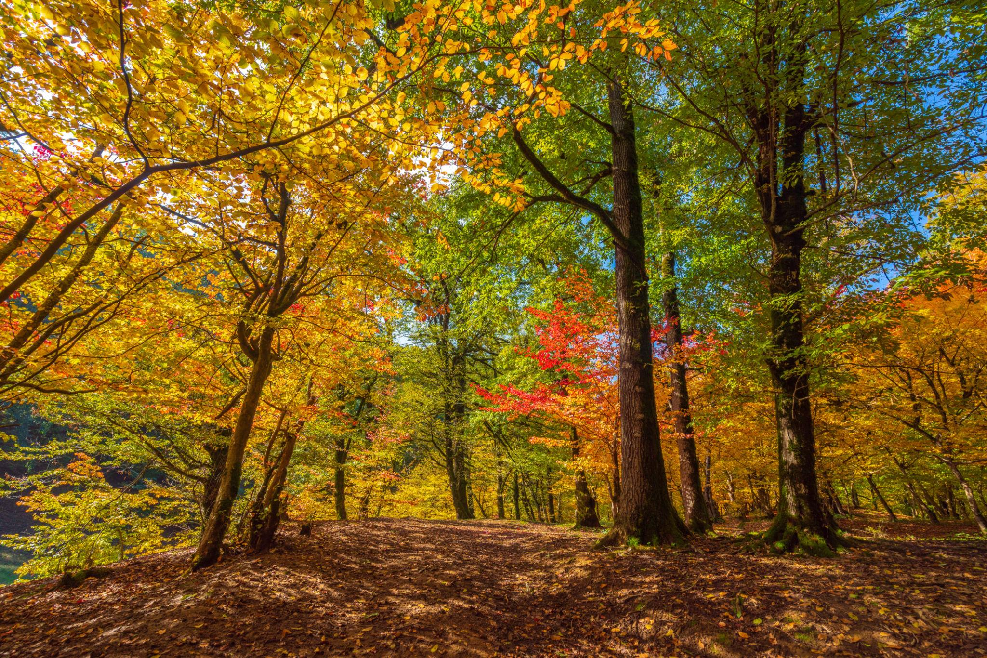
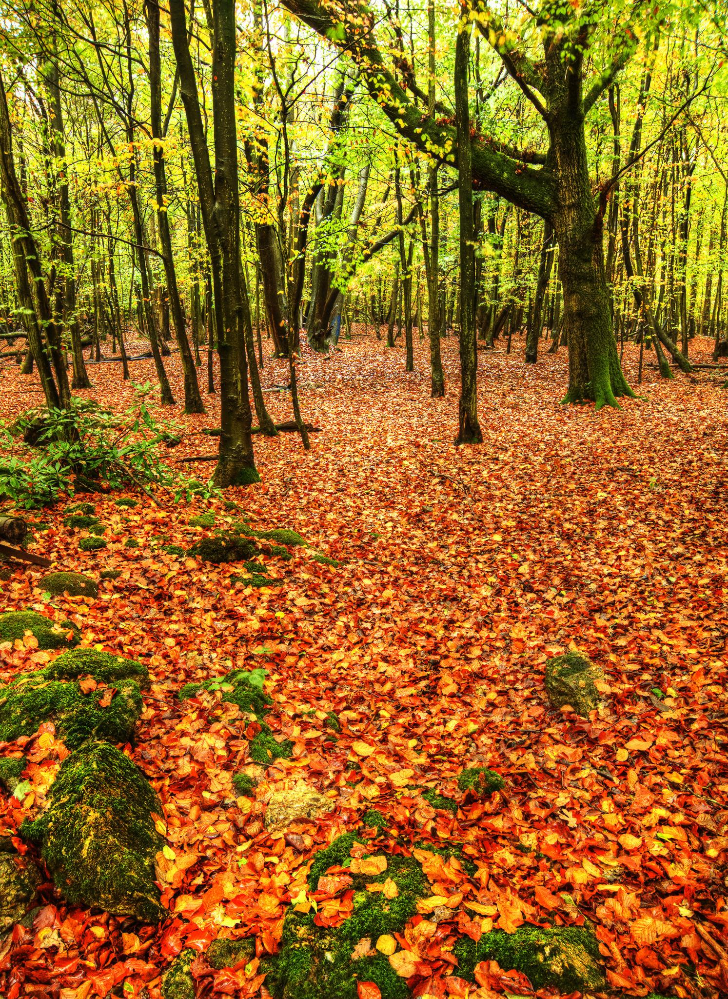
Characteristics
- Temperatures gradually decrease.
- Leaves change color.
- Many trees shed leaves.
- Daylight becomes shorter.
Typical months (Northern Hemisphere):
- September
- October
- November

4. Winter
# Source: AI Source: Provided by: [Data Path: Persons Table -> ID Column: 1, Name_En Column: Motasem Essam] -> From: [ChatGPT] on [7/17/2026]
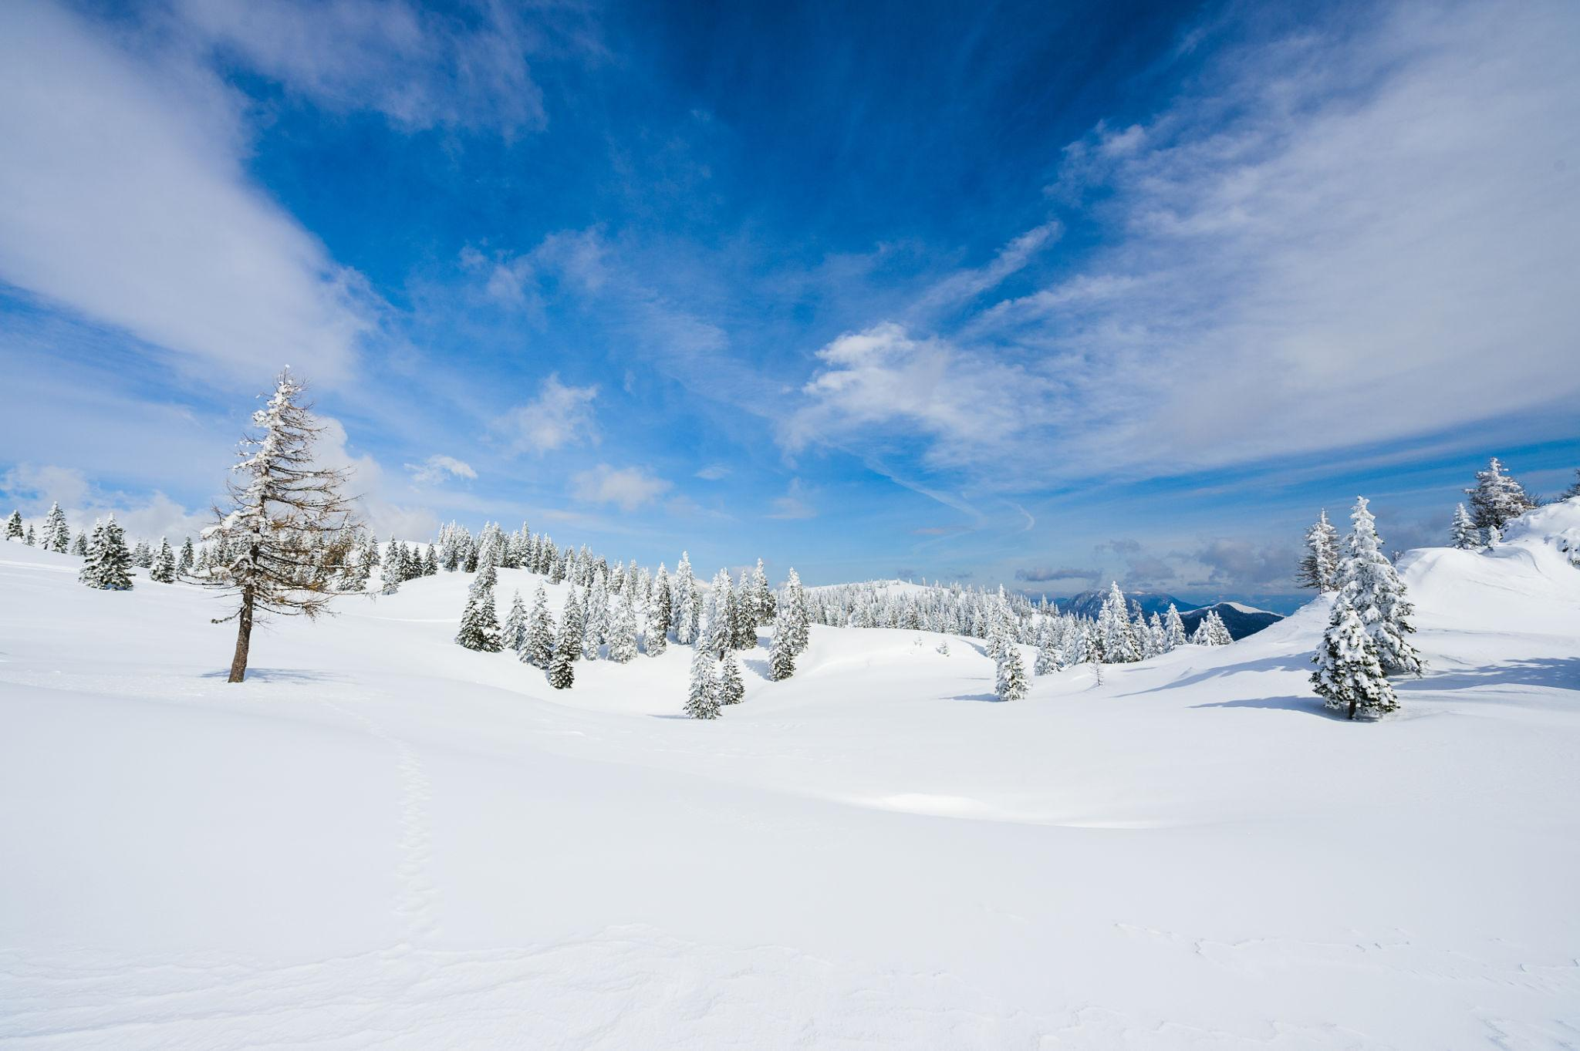
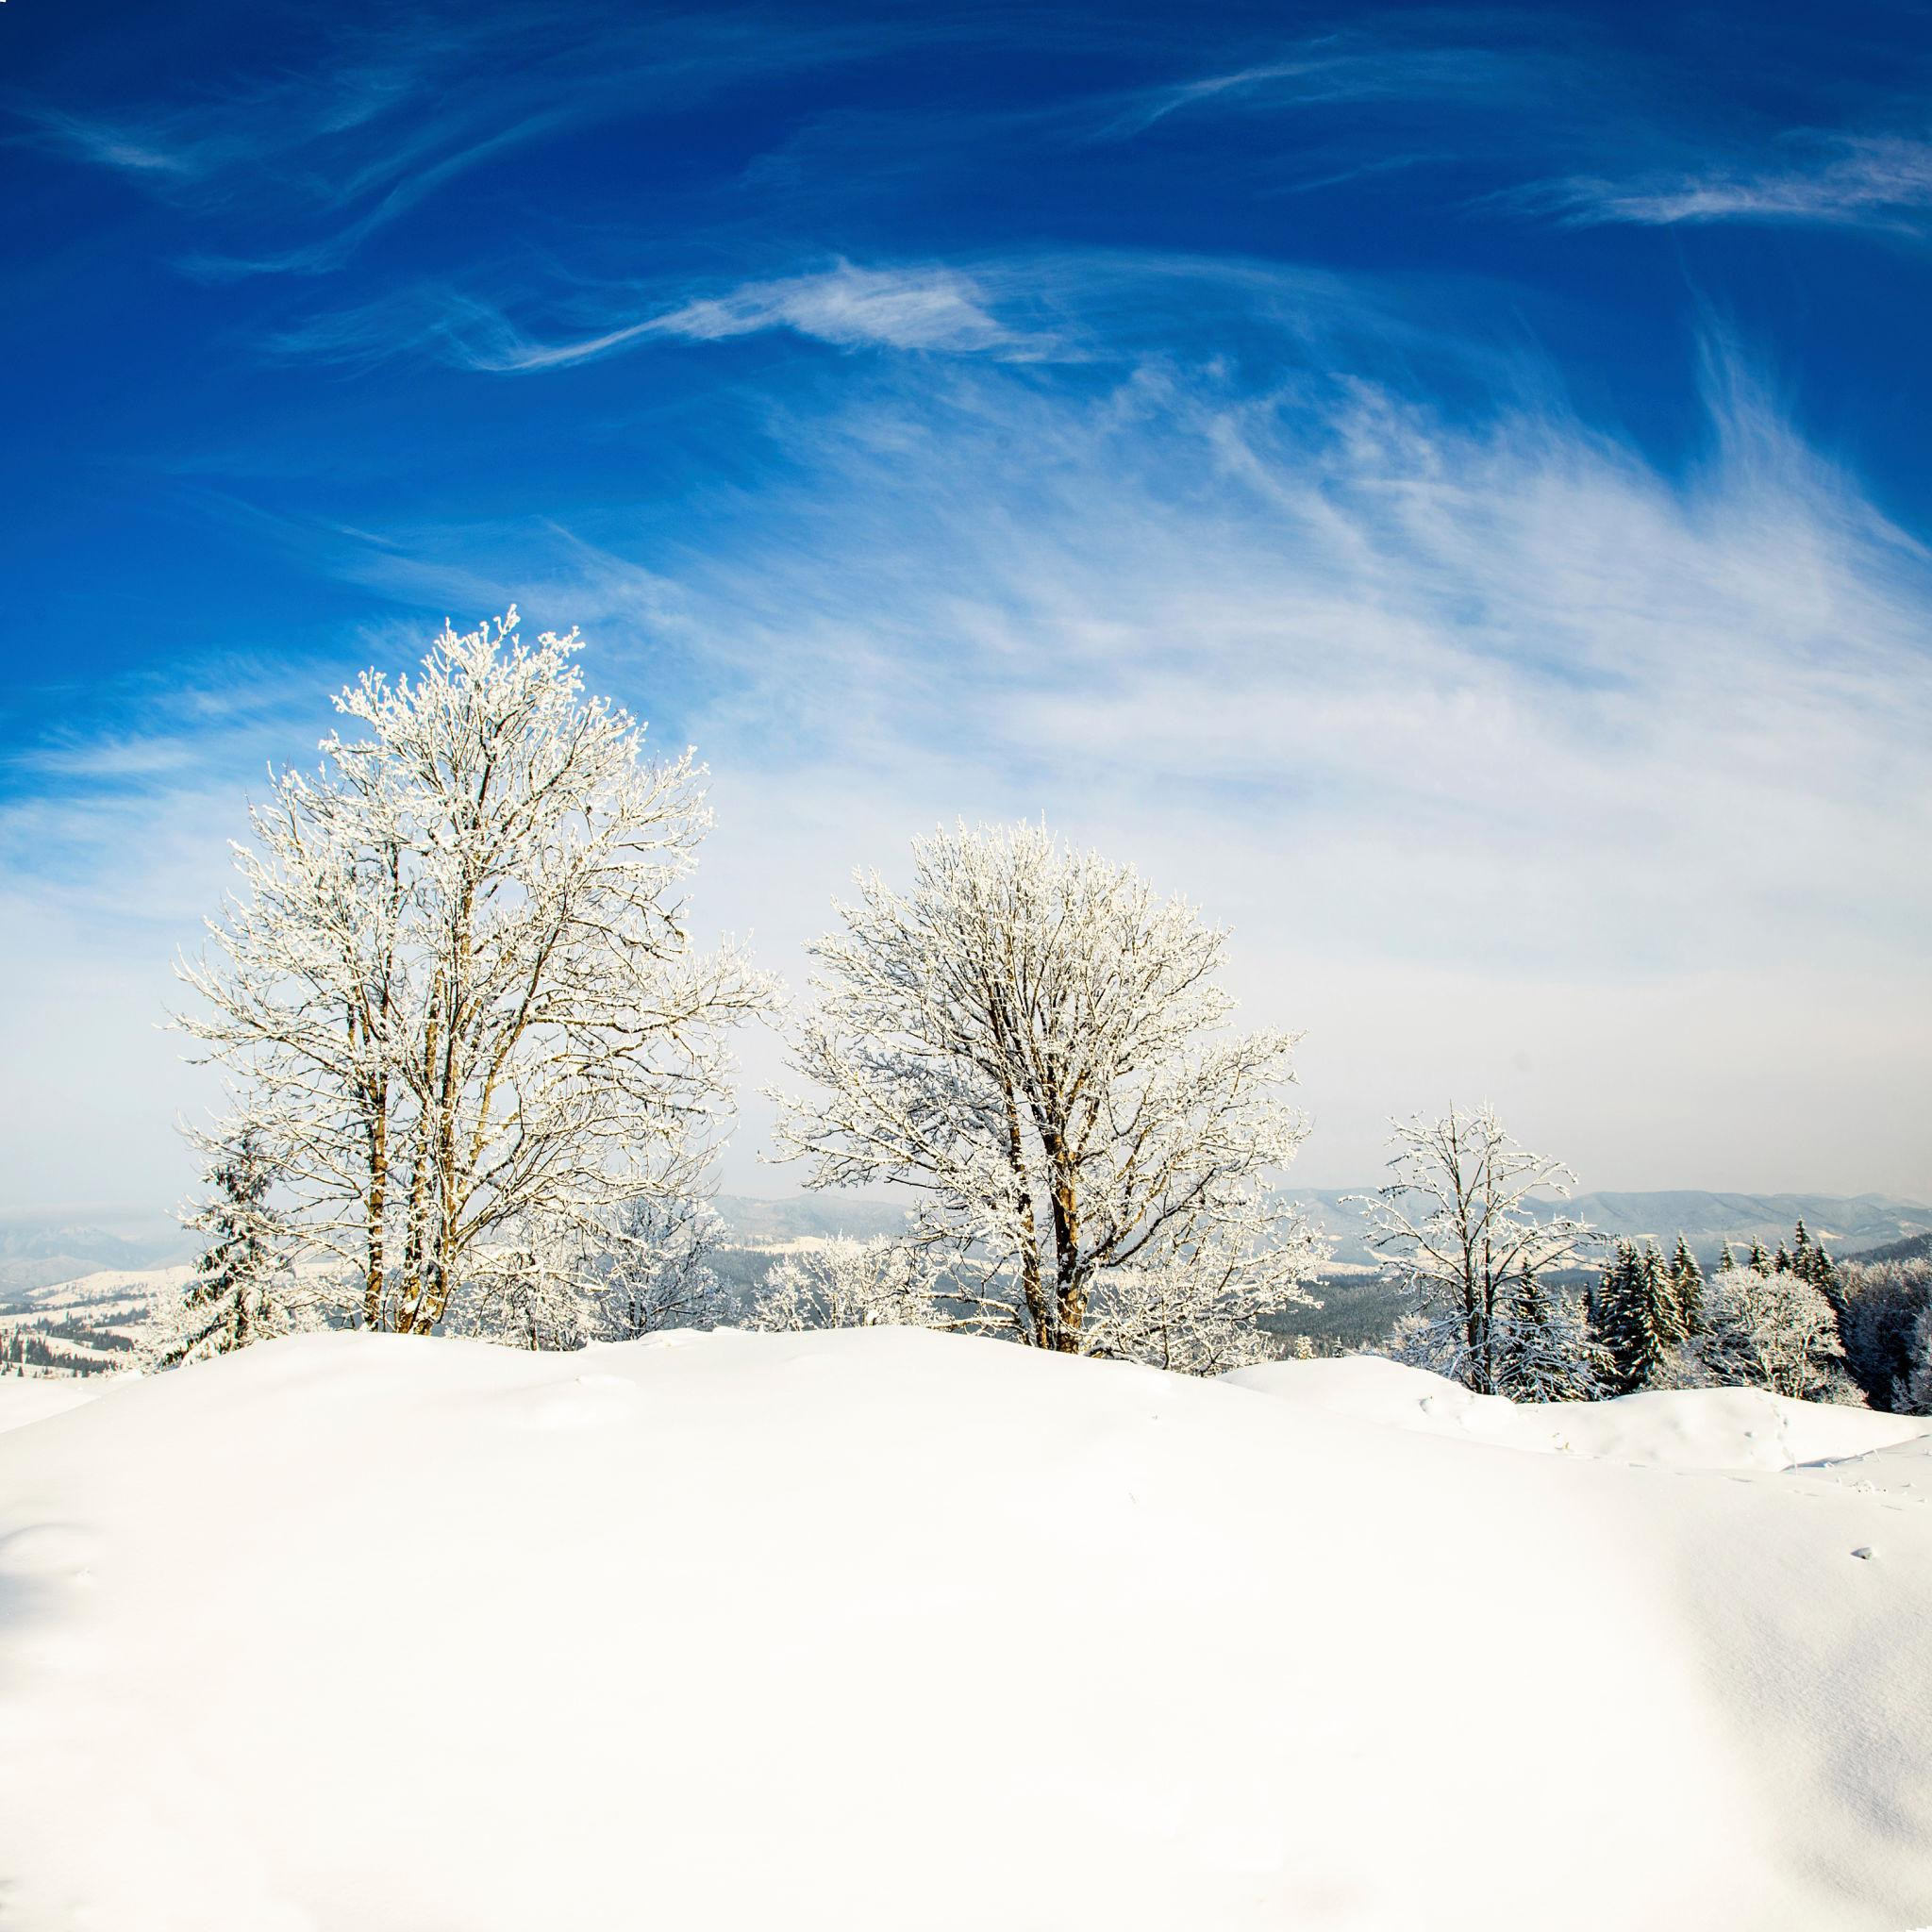
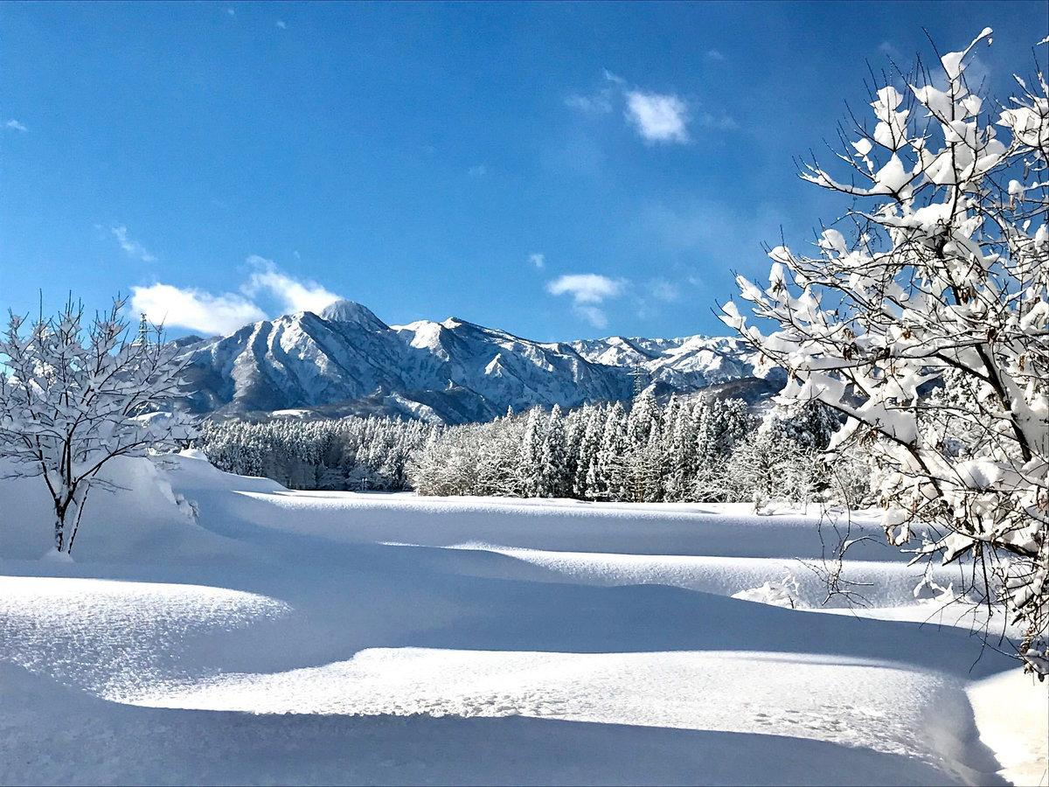
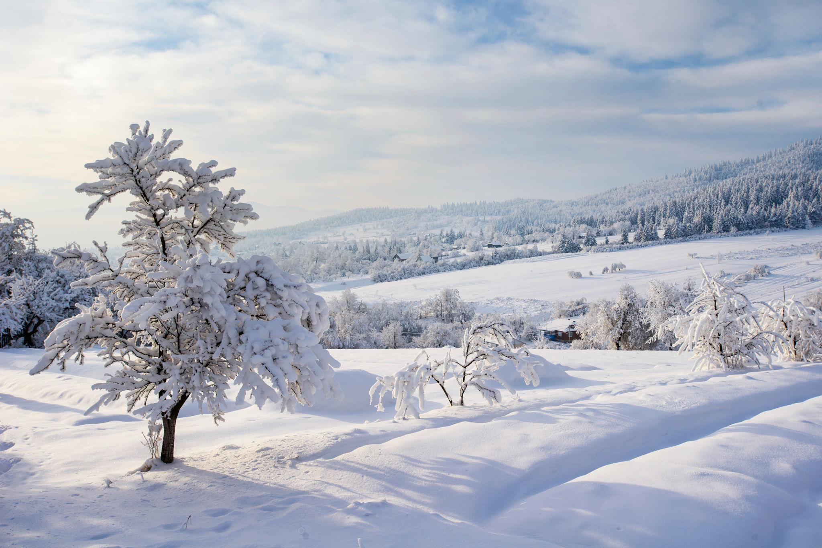
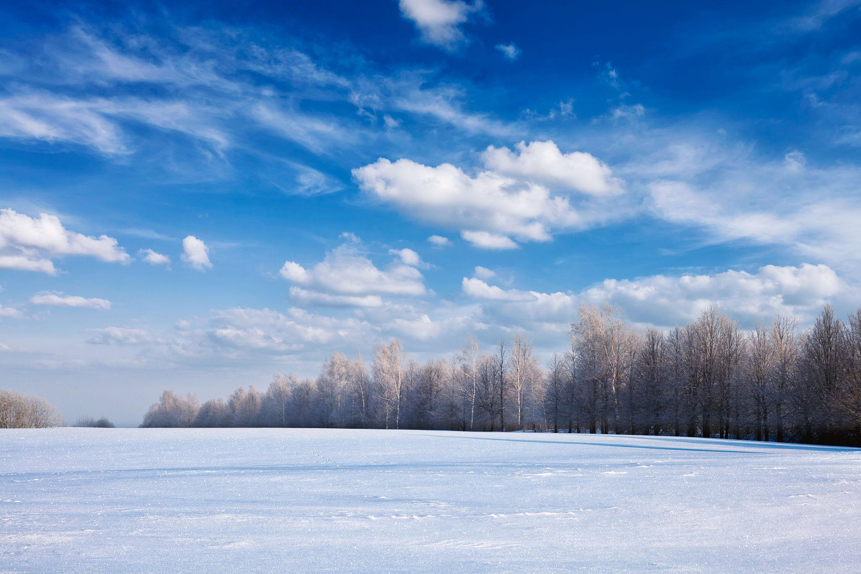
Characteristics
- Lowest temperatures.
- Shortest daylight hours.
- Snow in many regions.
- Dormancy for many plants.
Typical months (Northern Hemisphere):
- December
- January
- February

Opposite Seasons in the Hemispheres
# Source: AI Source: Provided by: [Data Path: Persons Table -> ID Column: 1, Name_En Column: Motasem Essam] -> From: [ChatGPT] on [7/17/2026]
Because of Earth's axial tilt:
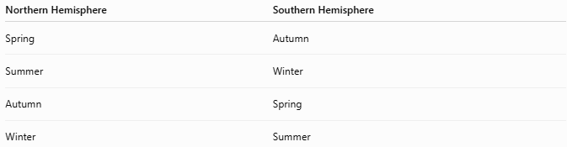
Northern Hemisphere | Southern Hemisphere
Spring | Autumn
Summer | Winter
Autumn | Spring
Winter | Summer
Example:
When it is July:
- Egypt → Summer
- Australia → Winter

Astronomical Seasons
# Source: AI Source: Provided by: [Data Path: Persons Table -> ID Column: 1, Name_En Column: Motasem Essam] -> From: [ChatGPT] on [7/17/2026]
The astronomical seasons begin at:
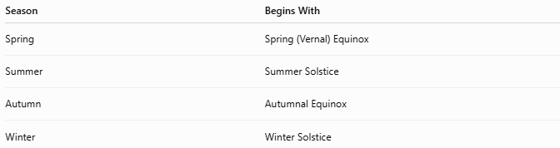
Season | Begins With
Spring | Spring (Vernal) Equinox
Summer | Summer Solstice
Autumn | Autumnal Equinox
Winter | Winter Solstice

Equinoxes
# Source: AI Source: Provided by: [Data Path: Persons Table -> ID Column: 1, Name_En Column: Motasem Essam] -> From: [ChatGPT] on [7/17/2026]
An equinox occurs when:
- Day and night are approximately equal in length worldwide.
There are two each year:
- Spring (Vernal) Equinox
- Autumnal Equinox

Solstices
# Source: AI Source: Provided by: [Data Path: Persons Table -> ID Column: 1, Name_En Column: Motasem Essam] -> From: [ChatGPT] on [7/17/2026]
A solstice occurs when the Sun reaches its highest or lowest position in the sky.
There are two each year:
- Summer Solstice
- Winter Solstice

Effects of Seasons
# Source: AI Source: Provided by: [Data Path: Persons Table -> ID Column: 1, Name_En Column: Motasem Essam] -> From: [ChatGPT] on [7/17/2026]
Seasons influence:
- Temperature
- Daylight duration
- Rainfall patterns
- Plant growth
- Animal behavior
- Agriculture
- Human activities

Applications
# Source: AI Source: Provided by: [Data Path: Persons Table -> ID Column: 1, Name_En Column: Motasem Essam] -> From: [ChatGPT] on [7/17/2026]
Knowledge of seasons is important in:
- Agriculture
- Meteorology
- Environmental science
- Ecology
- Tourism
- Transportation
- Education

Advantages of Seasonal Cycles
# Source: AI Source: Provided by: [Data Path: Persons Table -> ID Column: 1, Name_En Column: Motasem Essam] -> From: [ChatGPT] on [7/17/2026]
Seasonal changes:
- Support biodiversity.
- Regulate ecosystems.
- Guide farming cycles.
- Influence climate.
- Maintain natural biological rhythms.

Common Mistakes
# Source: AI Source: Provided by: [Data Path: Persons Table -> ID Column: 1, Name_En Column: Motasem Essam] -> From: [ChatGPT] on [7/17/2026]
- Believing seasons are caused by the Earth being closer to the Sun (they are caused primarily by the Earth's axial tilt).
- Assuming both hemispheres experience the same season simultaneously.
- Confusing weather (short-term atmospheric conditions) with climate (long-term average conditions).

Key Points
# Source: AI Source: Provided by: [Data Path: Persons Table -> ID Column: 1, Name_En Column: Motasem Essam] -> From: [ChatGPT] on [7/17/2026]
- Seasons result from:
  - Earth's 23.5° axial tilt
  - Earth's revolution around the Sun
- The four seasons are:
  - Spring
  - Summer
  - Autumn (Fall)
  - Winter
- Opposite hemispheres experience opposite seasons.
- Equinoxes and solstices mark the astronomical beginnings of the seasons.

Conclusion
# Source: AI Source: Provided by: [Data Path: Persons Table -> ID Column: 1, Name_En Column: Motasem Essam] -> From: [ChatGPT] on [7/17/2026]
Seasons are recurring divisions of the year produced by the Earth's axial tilt and its annual orbit around the Sun. These movements change the angle and duration of sunlight received in different regions, creating predictable variations in temperature, daylight, and natural conditions. The seasonal cycle plays a vital role in agriculture, ecosystems, climate, and human activities, making it one of the most important natural patterns on Earth.

